The Poster Sessions 2024 TSC - Organizing Your Information

Name/Description of Room Layout: Grand Ballroom, Loews

Sessions/Dates/Times:

P1 = Poster Session 1, Wednesday, April 24 Time: 7:00 PM -10:00 PM
P2 = Poster Session 2, Friday, April 26 Time: 7:00 PM -10:00 PM

Set Up: After 2 PM the day of your session.

Presenters must be available with their posters during their scheduled session to discuss their research with interested viewers. The Poster Sessions are a great showcase forum to inform colleagues, researchers, members of the press and other interested parties of your basic and clinical research projects. We encourage posters from: undergraduate and graduate students, researchers, post docs, authors, medical residents, fellows and professors, artists, designers, residents, fellows and professors, artists, designers, authors, and other professionals.

Poster Boards or Laptop Options

The Poster Boards are rented and provided by the Conference Organizers.
They are a high-quality fabric board and are heavy and cannot be easily moved.

If you are interested in having a TABLE/LAPTOP set up to show your poster/powerpoint slide please rsvp in advance. We have standard tables and some high-top tables. You will need to bring your own laptop.
If you would like to rent a large screen for your table area please contact us by March 1
Sections:
1.0: Philosophy
2:0 Neuroscience
3:0 Cog Sci/Psychology
4:0 Physics/Biology
5:0 Experiential
6: Humanities

Poster 'Board' Size:
4 ft. (height) x 8 ft. (width) with metal frame

Direction:
Horizontal

MAX Display Area:
(taking into account the metal frame) Your poster should not be larger than these dimensions; it can be smaller of course.

44 1/2 " x 91"

3.7 feet x 7.5 feet

1.1 m x 2.3 m

ADDITIONAL DIMENSIONS FROM FLOOR to Bottom of the Poster Board:

From floor to bottom of board 33 ½” 2.8 feet .85 m

From floor to top of board 81 ½” 6.8 feet 2.0 m

Organizing your Information
Focus on the introduction, methods, results and discussion, summary, and references. Make a small-scale sketch of your poster to ascertain if all the points you want to stress as well as headlines, text, figures and tables, photos, etc., will fit into the dimensions allowed. The poster should start in the upper left-hand corner and flow generally from left to right and from top to bottom. The title, author name(s) and affiliation are often at the top of the poster. If necessary, use letters, numbers, or arrows to indicate proper flow to the audience.

Content
Do not crowd too much information into the presentation; concentrate on a few main points. Highlight trends and comparisons with simplified graphics and diagrams. Often it is better to use outlines and bullets than paragraphs. Avoid overwhelming the audience with too many numbers, words, or complicated graphs. Make certain your message is clear because people will study your poster while you are away.

Lettering
All lettering should be easily read from a distance of 1 meter (4-5 feet) Use a bold or semi bold typeface for headings and labels. Lettering for subheads and figure captions should be larger than that of the main text but smaller than the main heading. Text in upper- and lower-case letters is more readable than all capitals, but capitals for headings and labels are acceptable. Use sans serif type such as Arial or Lucida Sans for text. It is much easier to read than serif type such as Courier.

All posters should feature a title, your name, and the name of the institution where the research was performed and should credit others, as appropriate. The title lettering should be about 2” to 3” (5” to 7.5”) with subheadings ½” to 1” high (1.25 to 2.5 cm).

Mounting = USE THUMB TACKS or PUSH PINS ONLY

ONLY
Do not use double sided tape, glue or Velcro.
Use push pins only. **(basic pushpins will be supplied)
You may not mark, paste, mount or write on any of these boards.
No adhesives. No Foam Boards. No Nails. Some magnets will work on the frame sides as long as they do not harm the boards. Please remove your poster after your session

To summarize:
- Use large, easy-to-read sans-serif letters.
- Include clear figures and tables and artwork.
- Do not just paste-up typed pages from a paper/ document
- Remember that a Poster Session is more like an informal discussion.
- The discussion may begin with a question from an interested person.
- You may initiate a discussion by pointing out the particular figure that depict the essential conclusions of your paper and allow questions and answers to flow from that point.
- Keep it conversational.

Business Cards/Flyers
You may wish to have copies of materials to give people who visit your poster

Removal of Posters
Please remove posters at the conclusion of your Poster Session.
Printer
If you wish to have your poster printed locally, we will put you in touch with a printer that can offer a group rate and deliver your posters to the hotel.

S A M P L E S
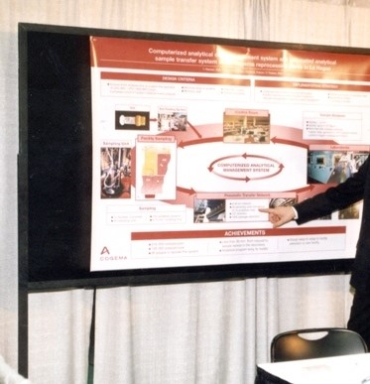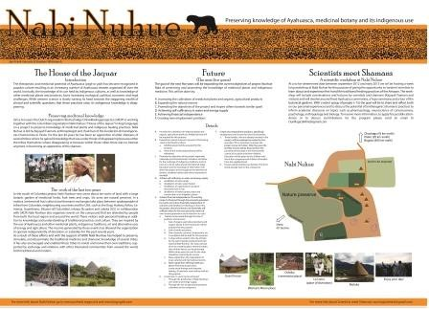
2012 FINAL Nabi Nuhue Poster/courtesy of Stephen Whitmarsh, PhD

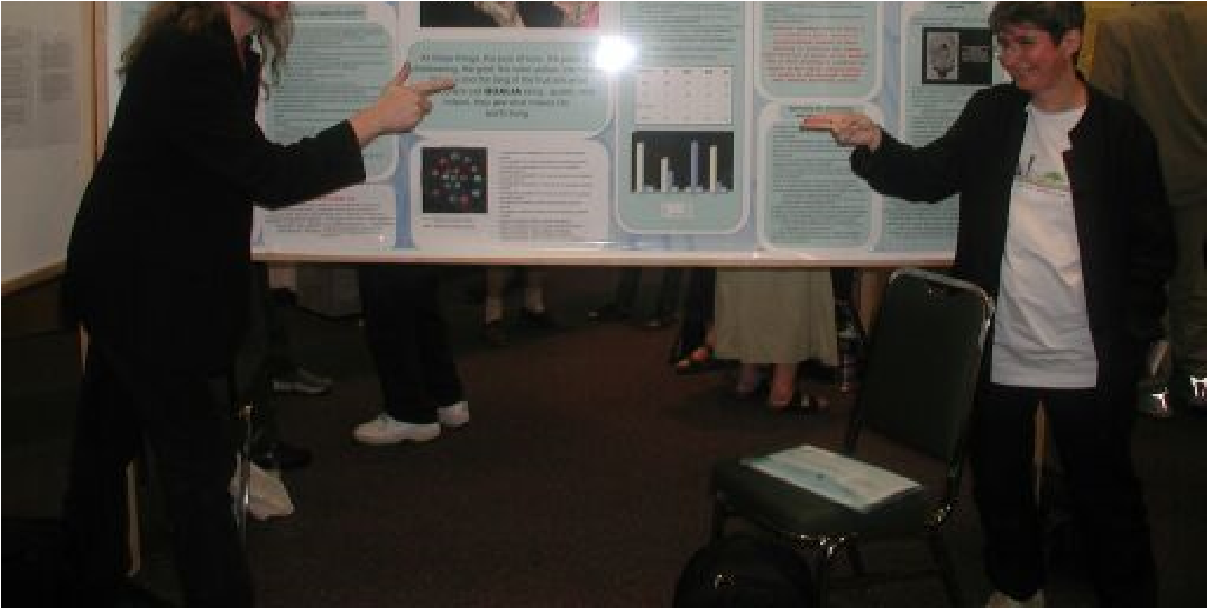
David Chalmers and Susan Blackmore - Here is another sample outline courtesy of Alex Vary

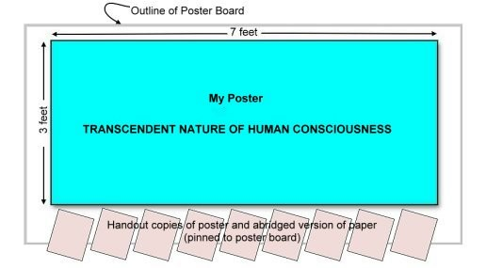

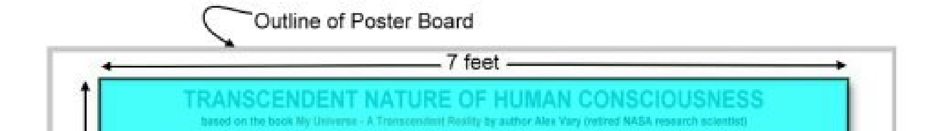
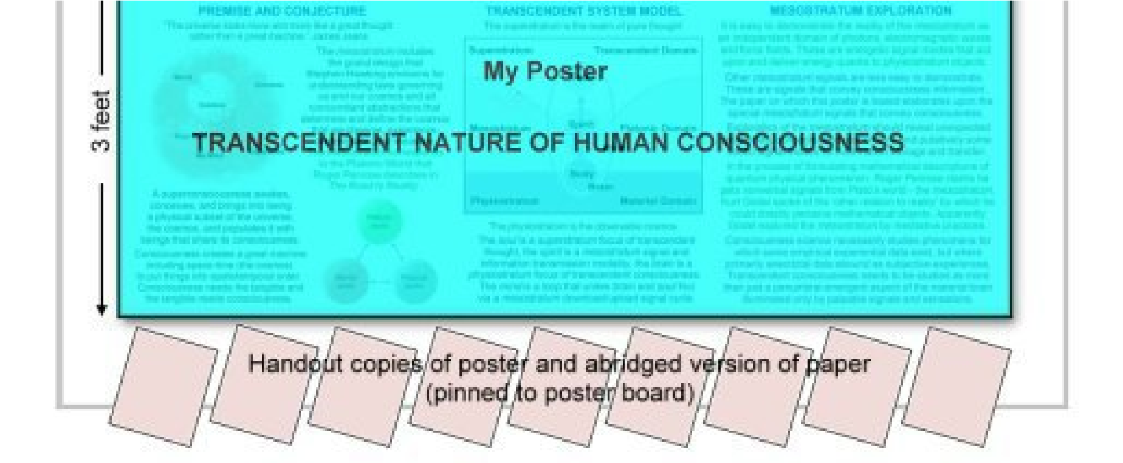

Prepared by TSC-CCS UArizona – ABM (Abi Behar Montefiore)

